Water Resources and Utilization in India
Booklet No. 26
Agricultural Situation in India: ASI - 1

Contents
Preface
I. Introduction
II. A Brief Study of World Water
III. Hydrologic Cycle
IV. Types of Water Resources Based on Uses
V. Water Resources in India
VI. Utilization of Water Resources
VII. Economic Use of Water Resources
VIII. Conclusion

Preface
Water is one of the basic resources needed to sustain plant and animal life and ultimately human existence. Judicious use of this resource should be the concern of all people. This booklet gives a brief amount of estimated water resources and its efficient use. This booklet describes the hydrologic cycle, types, utilization and economic use of water. This will enable the farmer to use the water more scientifically and economically.

Dr. K. T. Chandy, Agricultural & Environmental Education

I. Introduction

Water is an essential requirement of all living beings and indispensable for many human related activities. In nature it transports eroded material from mountains and forests to the plains and the sea. Man uses water to carry away his wastes, generate electric power, for navigation, industrial purposes and also as a source of recreation. Apart from all these, the role of water in agriculture is very significant Water is a limited resource and its efficient use is crucial to the survival of the human beings. Therefore, every effort must be made to make the best use of water so as to make possible a high level of continuous production. Several factors are to be kept in mind for the conservation and development of water resources. These are as follows:

1. availability and source of water;
2. climatic condition;
3. quality of water;
4. factors affecting water resources;
5. distribution and variation of rainfall & water resources;
6. competing demands; and
7. nature of the soil. .

II. A Brief Study of World Water

Total water in the world is estimated to be 1.5 billion cu km. About 95% of this is the salty water found in the oceans. This comes to around 1.425 billion cu km. Remaining 5% is fresh water i.e. only 75 million cu km. Out of this 75 million cu km 60 million cu km are immobilized as continuously frozen polar ice and snow, leaving only 15 million cu km as fresh liquid water for human, animal and plant needs. The world reserve of water resources is given in Fig. 1.

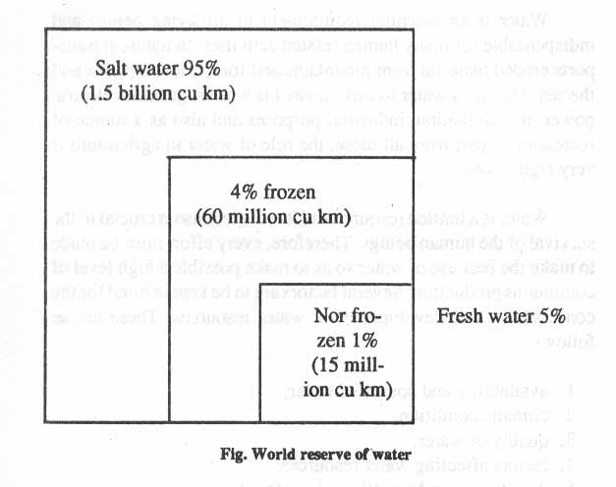 Fig. 1. World Water Resources

Of the 15 million cu km of fresh water about 1 % (150,000 cu kin) is surface water found in rivers, lakes and streams and 99% is stored underground at varying depths. About half of this ground water (7,000,000 cu km) is stored at depths greater than 1000 metres and is considered too expensive to pump to the surface for most uses. So total usable water in the world is 7 million cu km of fresh ground water at reasonable depth plus the 1,50,000 cu km of surface water.

III. Hydrologic Cycle

Consumable water is obtained through precipitation. Precipitation occurs by the unending moisture cycle of the earth called hydrologic cycle. Moisture is constantly circulating between the land, the ocean and the atmosphere. This hydrologic cycle has neither a beginning nor an end. Radiation from the sun evaporates water from ocean, lakes, rivers into the atmosphere. Transpiration also takes place from the vegetation and adds water to the atmosphere. The water vapour rises and collects to form clouds. Under certain conditions, the cloud moisture condenses and falls back to the earth as rain, hail, sleet or snow. The whole process is diagrammatically given in two Figures 2a & 2b. The Hydrologic Cycle.

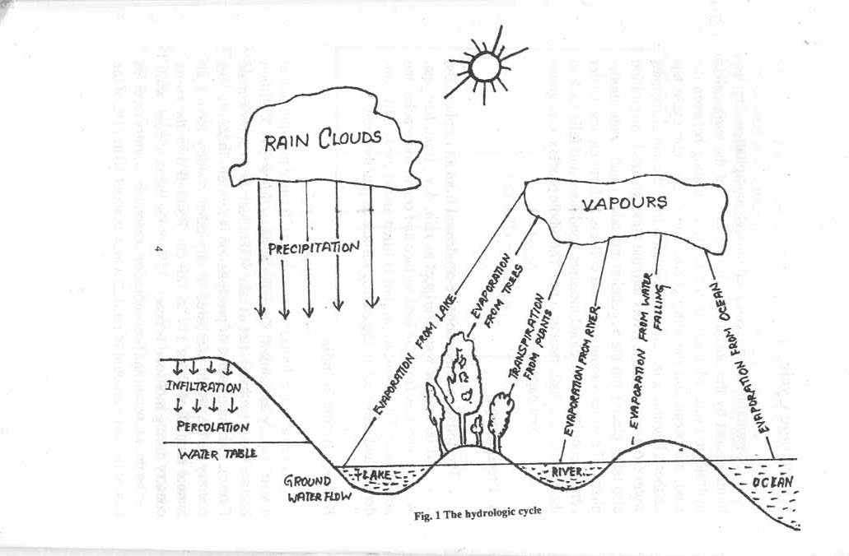

Fig. 2a. Hydrologic cycle.

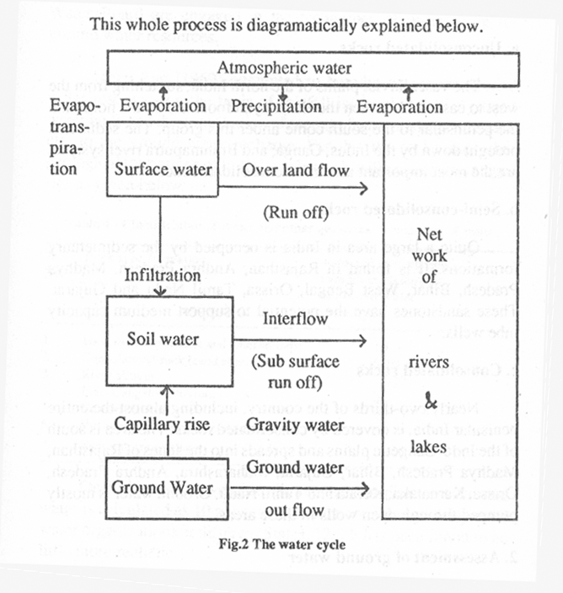

Fig. 2b. Hydrologic cycle.

A. Precipitation
Precipitation is the moisture condensed from atmosphere and deposited on land or water surfaces as rain, dew. frost, hail, etc. Water evaporates from the land surface and ocean and reaches the atmosphere. This moisture in turn is lifted and is eventually condensed and falls back to the earth's surface as precipitation.

B. Precipitation in India
On an average, India receives about 120 cm of precipitation in a year, mostly as rainfall. .On volume basis this is 394.5 million hectare metre (m. ham). (let us take 400 m. ha m as an approximate figure). The main source of precipitation is rainfall. India is a vast country in the world compared to any other country having an annual rainfall of about 117 to 120 cm. Rainfall over the entire country during monsoon is nearly 75% of the mean annual, while during pre-monsoon and post -monsoon seasons the country receives almost the same amount of rainfall which is about 10 to 11 % of the mean annual. In January and February the country receives just about 3.5% of the mean annual rainfall and it is mostly confined to Jammu & Kashmir, Himachal Pradesh, Po.jab, North-West U.P., North Bengal and Assam. Different monsoons is shown below in Tables 1 & 2 respectively.

Table 1 .Rainfall distribution In various states of India (in mm)

Sl.No. | States | Meteorological  Sub-divisions | Rainfall
1 | Andhra Pradesh | Costal  Telangana  Rayalaseema | 935  891  893
2 | North Eastern States | Arunachal Pradesh  Assam  Nagaland | 3736  2423  2065
3 | Bihar | Plateau  Plains | 1490  1267
4 | Gujarat | Gujarat  Saurastra | 1002  590
5 | Haryana | Haryana | 772
6 | Himachal Pradesh | Himachal Pradesh | 1971
7 | Jammu & Kashmir | Jammu & Kashmir | 967
8 | Karnataka | Costal  North Interior  South Interior | 3366  837  914
9 | Kerala | Kerala | 2961
10 | Madhya Pradesh | West  East | 1144  1470
11 | Maharastra | Madhya  Marathwada  Vidarbha  Konkan | 706  780  1124  2871
12 | Orissa | Orissa | 1486
13 | Punjab | Punjab | 760
14 | Rajasthan | West  East | 465  937
15 | Tamil Nadu | Tamil Nadu  Pondichery | 1008  1335
16 | Uttar Pradesh | East  Plains  Hills | 873  806  1840
17 | West bengal | Sub-Himalayan  Gangetic | 3079  1846

Note: The above mentioned figures are based on the total rainfall received from June to September during 1977-78.

On the basis of these, different regions of the country can be divided into three categories viz., high rainfall areas, medium rainfall areas and low areas. The areas receiving above 1,150 mm annual rainfall are high rainfall areas, those receiving between 750 and 1,150 mm are medium rainfall areas and the areas with annual rainfall below 750 mm are low rainfall areas.

Table 2 .Distribution and extent of rainfall through different monsoons

Sl.No. | Time & type of monsoon | % of rainfall
1. | South West monsoon (June to Sept) | 75
2. | Post monsoon season ((Oct to Dec.) | 10 – 11
3. | Winter season ( Jan to Feb) | 3-4
4. | Pre-monsoon season ( Mar to May) | 10-11
.
IV. Types of Water Resources Based on Uses

According to the uses water resources may be classified into three main groups.
1. For consumptive uses
2. Partially consumptive uses
3. Non consumptive uses

1. Consumptive uses
Irrigation, urban and rural water supplies are grouped in this ' category, since, in these situations, water is directly consumed by living beings.

2. Partially consumptive uses
Use of water for domestic and industrial purposes, thermal and nuclear power generation, etc. are partially consumptive as, a part of the water can be renewed for reuse after proper conditioning.

3. Non-consumptive uses
This includes the quantity required for hydro-power generation, navigation, pollution control, recreation, preservation of fish and wild life etc.

V. Water Resources in India

According to the placement, water resources of India are : divisible into two distinct categories:

A. Surface water resources
B. Ground water resources

The precipitation that falls on land is the ultimate source for both the categories of water resources.

A. Surface water resources
When rain falls, a sizable portion is intercepted by the vegetation, or temporarily detained in surface depressions. When the available interception or the depression storages are completely exhausted and when the rainfall intensity at the soil surface exceeds the infiltration capacity of the soils, the over land flow begins. This water reaches the rivers, streams, lakes, surface reservoirs, darns, etc. Our irrigation mainly depends on surface water resources. Runoff water from streams and rivers is stored in reservoirs or is diverted directly through canal system for irrigation. Water re- sources region can be planned on the basis of river basins.

1. River systems in India
Rivers are the main source of surface water. A river basin has well defined watershed boundary and also has relationship with ground water resources in most of the cases.

India has been divided into six river basins for the purpose of assessment of the available water resources. The following table will present the location, climatological factors, annual run-off and approximate volume of water of these six river basins. These are:
a. Indus basin
b. Ganga system
c. Brahmaputra system
d. East coast
e. West coast and
f. Rajputana region

Table 3 -Different river basins of India

Sl.  No. | Important  River basin | State in the region | Cath  Ment  Area  (m ha) | Avge  Annual  Precipi  Tation  M ha metre | Total  Precipi-  Tation  M ha  metre | Mean  Tempe-  Rature  ^{O}_{C} | Avg  Annual  Runoff  M ha  metre | Volume  Of Water  M ha  metre
1 | Ravi, Beas,  Sutlej | J & Kashmir, Punjab  Haryana  Himachal prade | 35.40 | 56.00 | 19.82 | 1260 | 07.94 | 04.93
2 | Ganga, Yamuna  Chambal gogra  Guwduk, Kosi | U.P. Bihar, M.P  Rajasthan & West Bengal | 97.60 | 111 | 108.3 | 16.80 | 48.96 | 18.50
3 | Brahmaputra,  Subausiri, Manar  Teest | Assam, Meghalaya,  Nagaland  West Bengal | 50.62 | 122 | 61.72 | 08.20 | 38.08 | 1.23
4 | Cavery, Krishna, Godavari, Mahanadi, Subarnarekha  Damodal | Madhya Prades  Bihar, Orissa,  West Bengal  A.P.  Maharastra  Karnataka  Tamil Nadu | 121 | 109 | 131.9 | 26.1 | 41.19 | 33.80
5 | Tapti, Narmada, Mahi, Sabarmati | Gujarat, Kerala  Maharastra  Karnataka | 49.16 | 122 | 59.98 | 25.5 | 31.06 | 6.92
6 | Luni & Ghagaoa | Rajasthan | 16.80 | 29.00 | 04.87 | 26.2 | - | 1.22
7 | Total |  | 370.61 | --- | 386.7 | --- | 167.2 | 66.6

The assessment of this surface reservoir is also calculated by lots of assumptions on run-off, rainfall temperature etc. So this resource can be an approximate figure. All these water resources cannot be utilized due to the limitations imposed by the physiographic factors.

Surface water stored in reservoirs or diverted directly is distributed for irrigation through the canal irrigation network. A canal starts either from a water storage dam or diversion darn. Irrigation water flows through the complete canal system before it reaches the farmer's field to be irrigated. The canal network consist- of canals, distributaries, water courses and field channels.

B. Ground Water Resources
The main source of ground water is rainfall. However, ground water recharge is supplemented by other sources such as seepage from canals and field channels, ponds, tanks, effluent drainage from rivers, deep percolation from irrigated fields, etc. A part of any of these water sources that infiltrates into surface soil may continue to move laterally at a shallow depth. This water which flows below the soil surface may eventually reach the stream channel. This flow of water below the surface is called sub surface run off. A part of the sub surface run-off may enter the stream promptly, whereas the remaining part may percolate deeply into the soil and remain above the water table in the zone of saturated flow. This water table shows the upper level of ground water in the earth.

The total run-off in the stream channel includes the melted snow, the surface run-off, the sub surface run-off and the ground water run -off. The portion of run-off water, after infiltration reaches the ground water table, together with the contribution made to ground water from a neighbouring basins, effluent rivers, natural lakes, ponds, artificial storage reservoirs, and canals irrigations r constitutes the ground water resources.

This whole process is diagramatically explained below Figure 2

1. Ground water regions or India
The availability and development potential of ground water in India on the basis of geological consideration can be described under the following three broad categories:

a. Unconsolidated rocks
b. Semi-consolidated rocks
c. Consolidated rocks.

a. Unconsolidated rocks
The vast alluvial plains of the north India, stretching from the west to east and between the Himalayan foot hills on the north and the peninsular to the south come under this group. The sediments brought down by the Indus, Ganga, and Brahmaputra river systems are the most important area of unconsolidated rocks.

b. Semi-consolidated rocks
Quite a large area in India is occupied by the sedimentary formations. It is found in Rajasthan, Andhra Pradesh, Madhya Pradesh, Bihar, West Bengal, Orissa, Tamil Nadu and Gujarat. These sandstones have the potential to support medium capacity tube wells.

c. Consolidated rocks
Nearly two-thirds of the country, including almost the entire peninsular India, is covered by consolidated rocks. The area is south of the Indo-Gangetic plains and spreads into the states of Rajasthan, Madhya Pradesh, Bihar, Gujarat, Maharashtra, Andhra Pradesh, Orissa, Karnataka, Kerala and TamiJ Nadu. Ground water is mostly pumped through open wells in these areas.

2. Assessment of ground water
As compared to surface water, ground water assessment is much more difficult due to various hydrologic components within the framework of a complex geological environment

Many attempts have been made to assess the ground water. For accurate assessment, detailed and authentic information relating hydrogeological formation and the water balance of the entire country is required. Geological survey of India and Central Ground Water Board are engaged in the techniques of prospecting for ground water resources.

Ranga Rao (1969) attempted to broadly assess the ground ! water resources on the basis of rainfall infiltration to the ground water body and the contribution of seepage from canals, ponds, tank etc. to the ground water recharge. For this the rocks and other geological formations of India have been classified in seven categories as given below:

Table 4 .Classification of rocks and other geological formations of India

Sl.No. | Rock type formation | Assumed % rainfall contribution of ground water recharge
1 | Hard rock formations and Deccan traps | 10
2 | Consolidated rock (sand stone) | 5-10
3 | River alluvia | 15-20
4 | Indo-Gangetic alluvium | 20
5 | Coastal alluvia | 10-15
6 | Western Rajasthan dune sand | 2
7 | Inter.montane valleys | 15-20

On the basis of above table, the average contribution to ground water is calculated as 10 per cent But after considering the ground water organizations at different States, 12.5% has been found to be little more realistic.

Reckoning that the total volume of rainfall is about 400 m ham, when we consider the average rainfall is 120 cm over geographical area of 328 m ham. The main rainfall contribution to groundwater is 12.5% of the total volume of rainfall i.e. 56 m. ha m. The supplement from other sources, seepage from canals, water courses, field channels, ponds tanks, return flow from irrigation in the field and the effluent recharge from rivers is 4 m. ha m. The total volume of surface water utilized for irrigation is about 23.5 m. ha m. It is visualized that 35% of this total volume is diverted for irrigation would pass as deep percolation to the ground water storage. So the addition to the ground water on account of irrigation may be taken as 8.2 m. ha m. The total volume of ground water presently used for irrigation is estimated at about 10.5 m ham. It is assumed that 25% of the irrigation water is contributed to the ground water as deep percolation. So the total ground water is roughly visualized to be accounted for as below:

Table 5 .Total ground water

Sl.No. | Recharge sources | Amount in  m.ha m
1 | Recharge from rainfall | 50.00
2 | Recharge due to irrigation by surface water | 8.20
3 | Recharge due to irrigation from ground water | 2.75
4 | Recharge from effluent rivers. ponds. streams etc | 4.00

VI. Utilization of Water Resources

Water resources are utilized mainly for three purposes:
- Irrigation
- Industrial
- Domestic

Out of these three, irrigation is the major consumer of water resources. The total utilization of water in India is depicted in the following flow-chart in Figure 3. on the Total Precipitation.

Total Precipitation

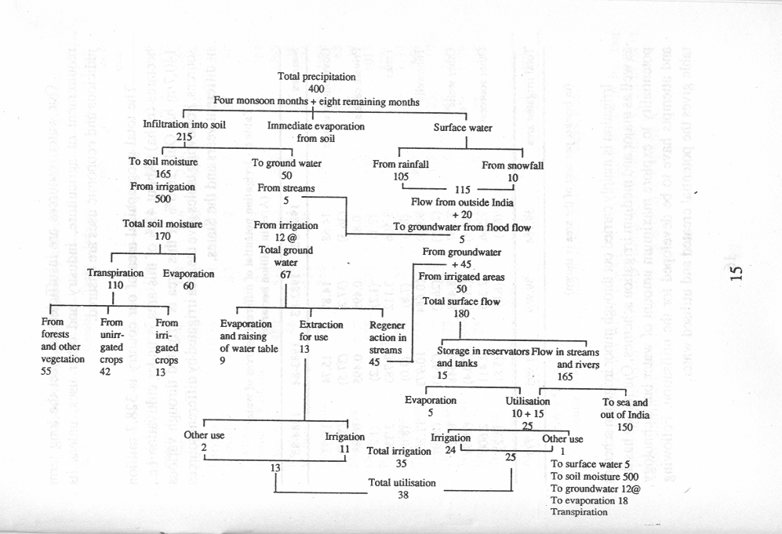

Our water resources are insufficient to meet the long term requirement of agriculture, industry and other uses, unless its judicious and economic uses are ensured.

The total geographical area of our country is 328.7 million hectares (m.ha). About 42% of this area is under cultivation i.e., 140.7 m ha. Only 26.6% of this area is irrigated through various sources. Following tables give the area irrigated by different sources indifferent years and the States.

Table 6 .Irrigation potential or different sources or water
(Area in million hectars)

Sl.No. | Sources | 1981-82 | 1982-83 | 1983-84 | 1984-85
1 | Government canals | 14.68  (36.3) | 14.87  (37.2) | 15.74  (37.5) | 15.33  (36.5)
2 | Private canals | 0.84  (2.1) | 0.495  (1.2) | 0.495  (1.2) | 0.495  (1.2)
3 | Tanks | 3.506  (8.8) | 3.112  (7.8) | 3.783  (9.0) | 3.330  (8.0)
4 | Tubewe/ls | 9.900  (24.9) | 10:684  (26.7) | 10.973  (26.I) | 11.265  (26.9)
5 | Other wells | 8.267  (20.8) | 8.428  (21.1) | 8.548  (20.4) | 8.723  (20.9)
6 | Other sources | 2.566  (6.5) | 2.375  (6.0) | 2.411  (5.8) | 2.600  (6.2)
7 | Total irrigated area | 39.764 | 39.969 | 41.995 | 41.779

(in bracket per cent of the area is shown)
Irrigation is mainly carried out through minor irrigation schemes as well as major and medium irrigation schemes. Our nation has the potentiality to explore maximum amount of water but technology and attempts have to be developed for the utilization. Following table gives the potential created and utilized water.

Table 7. Net area irrigated by different sources (in thousand ha)

Sl  .No. | States | Canals | Tanks | Tube  wells | Other  wells | Other source | Total  Irrigat  ed area
1 | Andhra Pradesh | 1627 | 1100 | 114 | 470 | 126 | 3437
2 | Assam | 362 | --- | --- | --- | 210 | 572
3 | Bihar | 896 | 118 | 846 | 225 | 475 | 2760
4 | Gujarat | 245 | 25 | 130 | 999 | 15 | 1414
5 | Haryana | 1036 | 1 | 682 | 31 | 4 | 1754
6 | Arunachal pradesh | --- | 0.5 | 2 | 1 | 87 | 90
7 | Jammu & Kashir | 280 | 0.5 | 2 | 1 | 11 | 302
8 | Karnataka | 480 | 410 | 0.5 | 336 | 131 | 1365
9 | Kerala | 86 | 58 | 54 | NA | 30 | 228
10 | Madhya Pradesh | 801 | 132 | 26 | 700 | 145 | 1804
11 | Maharastra | 379 | 260 | -- | 1046 | 117 | 1802
12 | Manipur | --- | --- | --- | --- | 65 | 65
13 | Meghalaya | --- | --- | --- | --- | 37 | 37
14 | Orissa | 655 | 233 | NA | 127 | --- | 1015
15 | Punjab | 1383 | -- | 1559 | 172 | 7 | 3121
16 | Rajasthan | 887 | 53 | 50 | 1219 | 30 | 2547
17 | Tamil nadu | 911 | 750 | 62 | 807 | 35 | 2565
18 | Tripura | --- | 2 | --- | 0.5 | 23 | 30
19 | Uttar pradesh | 2473 | 330 | 3189 | 1314 | 349 | 7933
20 | West Bengal | 960 | 303 | --- | 17 | 209 | 1409
21 | Union Territores | 28 | 3 | 45 | 7 | 35 | 118
All India |  | 13775 | 3986 | 6469 | 7557 | 2304 | 34491
NA = Not Available
Source: Water Use Efficiency in Agriculture by S. Giriappa, P.35.

Total ground water resources can irrigate 42.29 m ha, but present utilization is only 10.01 m ha and remaining 32.28 m ha is left unutilized, though there is a potential to explore it.

VII. Economic Use of Water Resources

Water is the most critical input in crop production. It also influences almost all the bio-physiological processes of plants. When we speak of economic use of water, it refers to the system which aims at optimum utilization of available water resources in crop production without adversely affecting soil health. As we have discussed earlier the main source of water for plant growth is irrigation, so while irrigating following important points are to be kept in mind. These are:

--when to irrigate
--how much to irrigate
--how best to irrigate

Determination of water requirement and criteria for scheduling irrigation help to define when to irrigate. The estimation of plant available moisture and deficit expressed as depth in the rooting zone enables to decide how much to irrigate. Selection of suitable method of irrigation in a given situation will meet the question how best to irrigate. Some other measures for efficient management of irrigation water are discussed as below.

1. Check water logging
It is one of the major problems in water management. The concept of plant available water capacity enables one to avoid application of excess water which further helps to minimize water- logging along with salinity and alkalinity. Frequent irrigations maintain high soil moisture regime but it depends on the method adopted for irrigation.

2. Drainage
To avoid water logging condition and salt accumulation, the field should be provided with a proper drainage system. The drainage provides suitable environment to the development of plant root system and helps in optimizing crop production.

3. Disiltation of tanks
Siltation of tanks and reservoirs both traditional and modem, has added to the gravity of problem of surface water management. It reduces the storage capacity of the reservoir or tanks and increases in the volume and velocity of floods. Disiltation may be difficult for the big reservoirs but this can be easily practised in tanks, ponds, ditches etc.

4. Ground water management
Management of surface water and ground water are equally important in water harvesting and recycling. In areas that greatly depend on ground water for their irrigation requirement, should be ensured that crops are provided with water during the critical period of their growth. For this exploitation of ground water should be managed in a balanced manner.

Total amount of precipitation received is constant, and it’s economical use is the only way to increase production. At present, 29% of the total precipitation is lost through surface run-off and 53% through infiltration. For better management of ground water, the ultimate aim is to increase from 53% of the total precipitation moving into the soil to 100 per cent. This will recharge to ground water.

Ground water availability gets considerably reduced due to increased exploitation and poor recharge conditions. Therefore, proper water balance between availability, recharge and exploitation should be maintained. For this, a proper study and planning is very necessary"

5. Watershed management
Watershed is the geographical area from which the entire surface run-off originating due to the rainfall coverage flows through the existing drainage system towards a common outlet Let us say, it is a small catchment area in which the excess water of that particular region resulting from run-off is conserved either by check darns or by gully plugs or through percolation ponds.

An important planning input is watershed management is to conduct the ground water study. This study is undertaken to assess the ground water status, soil types and water stored at various depths. With this information it will be possible to plan properly the optimum utilization of the available water.

VIII. Conclusion

The above discussion underlines the fact that in the face of anticipated population growth and technological advancement, the country's utilizable water resources are limited and there is no ground for complacency in the matter. There is utmost need for laying maximum emphasis on conservation and most efficient utilization of the available water resources. Technological and management capabilities will have to be upgraded for this purpose.

%%%%%%%%%%%%%%%%%%%%%%%%%%%%%%%%%

